Rt Hon Oliver Dowden CBE MP
Secretary of State for Digital, Culture, Media and Sport
4th Floor
100 Parliament Street
London SW1A 2BQ

www.gov.uk/dcms
enquiries@culture.gov.uk

INT2020/07599/DC
22 May 2020

All MPs in England

Dear Colleague,

Coronavirus Community Support Fund

I am writing to draw your attention to the government’s Coronavirus Community Support Fund, which opens to applications today.

Charities and social enterprises are playing a vital role up and down the country, meeting the needs of vulnerable people affected by the current crisis. At the same time many have been experiencing significant challenges as they have had to close shops and other revenue-generating services, and cancel fundraising activities.

To ensure that our charities and social enterprises can continue to step up to respond to the crisis, and keep their doors open to those most in need, the government has made available an unprecedented package of support, including £750m targeted specifically at these sectors.

The £200m Coronavirus Community Support Fund forms a central part of this package, and is being administered through the National Lottery Community Fund (NLCF). From today charities and social enterprises in England can submit applications through the NLCF website (www.tnlcommunityfund.org.uk).

The Fund has two key objectives:

- To increase community support to vulnerable people affected by the Covid-19 crisis, through the work of civil society organisations.
- To reduce temporary closures of essential charities and social enterprises, ensuring services for vulnerable people impacted by Covid-19 have the financial resources to operate, and so reduce the burden on public services.

Grants will allow organisations to meet service costs, where they are experiencing increased demand and/or short term income disruption. Grants will also allow organisations to refocus services to address more immediate beneficiary needs in light of Covid-19.

I have no doubt that you will know of charities and social enterprises in your constituencies and communities delivering essential services. Where you believe an organisation could benefit from this type of funding, please direct them to the NLCF website for more information.

I also wanted to take this opportunity to highlight some of the other sources of support for these sectors which the government has made available. We have allocated £160m to other government departments, which will support the work of charities and social enterprises delivering services that are central to their policy agenda and public services. Departments are disbursing these funds in a range of ways. The following funds are currently open for organisations to apply to:

- The £3.45m Covid-19 Food Charity Grant Scheme to provide immediate support to keep food charities and front-line food aid charities open and supporting the vulnerable, due to the economic impacts of Covid-19, with a continual supply of food otherwise not accessed through usual routes.
- A £10m Domestic Abuse Safe Accommodation Fund: COVID-19 emergency support fund to support domestic abuse safe accommodation services who provide beds and offer the critical help victims and their children need.
- The £6m Covid-19 Impact Programme to ensure that people from Armed Forces communities can keep accessing important services, where resources for these services have been impacted by the Covid-19 pandemic.
- The £5m Loneliness Covid-19 Grant Fund National organisations working to tackle loneliness and build social connections are invited to apply for a share of £5 million of funding, which the government is investing to help them to continue and adapt their critical work.
- The £6m Covid-19 Homelessness Response Fund to provide emergency funding to homelessness charities directly affected by the Coronavirus.

We have also matched the £35m raised by the BBC’s Big Night In, with the first £20m of this match funding going to the National Emergency Trust, to distribute through local community foundations, and the remainder to support the work of Children in Need and Comic Relief. Again, I would encourage local charities you are aware of to consider applying for this funding. Details on how it is being distributed and how to apply can be found on each organisation’s website:

- www.ukcommunityfoundations.org/our-network
- www.bbcchildreninneed.co.uk/grants/apply/
- www.comicrelief.com/the-big-night-in-how-you-are-helping

Charities and social enterprises are an essential part of our response to the extraordinary crisis we find ourselves in. I know that across the political spectrum we will all want to help as many of them as possible access the support they need. I look forward to updating you on progress with our vital work.

Yours sincerely,

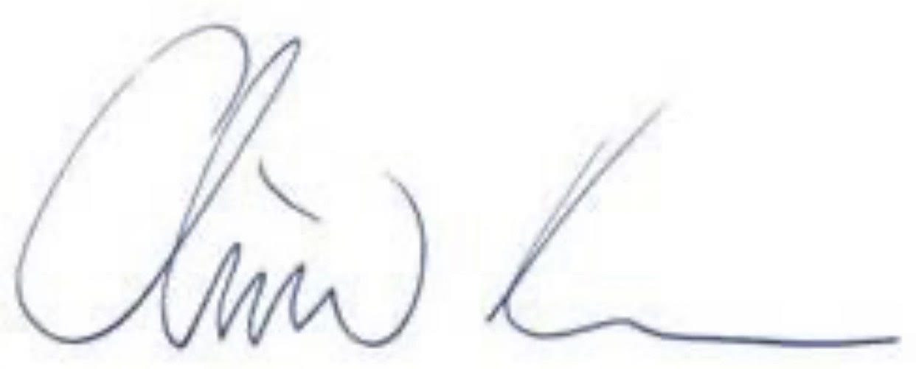

Rt Hon Oliver Dowden CBE MP
Secretary of State for Digital, Culture, Media and Sport

